“ TEXTILE STORE BILLING SYSTEM ”

A Project Report submitted
In partial fulfillment of the requirements for the award of the degree of
BACHELOR OF TECHNOLOGY IN
COMPUTER SCIENCE & ENGINEERING (DATA SCIENCE)

Submitted by
VARANASI HARSHA VARDHAN
Regd No. 2025094579

Under the esteemed guidance of

Dr. Devarapalli Ravi Kishore, Associate Professor, CSE DS



DEPARTMENT OF COMPUTER SCIENCE AND ENGINEERING (DATA SCIENCE)

GITAM SCHOOL OF TECHNOLOGY
GITAM (Deemed to be University)
VISAKHAPATNAM
2025

DEPAR.
TMENT OF COMPUTER SCIENCE AND ENGINEERING (DATA SCIENCE)

GITAM SCHOOL OF TECHNOLOGY
GITAM (Deemed to be University)



DECLARATION

I hereby declare that the project report entitled “TEXTILE STORE BILLING SYSTEM” is an original work done in the Department of Computer Science and Engineering (Data Science), GITAM School of Technology, GITAM (Deemed to be University) submitted in partial fulfillment of the requirements for the award of the degree of B.Tech. in Computer Science and Engineering. The work has not been submitted to any other college or University for the award of any degree or diploma.

Date:

Registration No Name Student Signature
2025094579 HARSHA VARDHAN VARANASI
DEPAR.
TMENT OF COMPUTER SCIENCE AND ENGINEERING (DATA SCIENCE)
GITAM SCHOOL OF TECHNOLOGY
GITAM (Deemed to be University)



CERTIFICATE

This is to certify that the project report entitled “TEXTILE STORE BILLING SYSTEM” is a bonafide record of work carried out by HARSHA VARDHAN VARANASI, Regd No 2025094579, submitted in partial fulfillment of requirement for the award of degree of Bachelors of Technology in Computer Science and Engineering (Data Science).

Date :

Project Guide
Dr. Devarapalli Ravi Kishore Associate Professor

. TABLE OF CONTENTS

S.No | Description | Page No.
1. | Introduction 6
2. | Aim of the Project 6
3. | Problem Definition & Objectives 7
4. | Code For TEXTILE STORE BILLING SYSTEM 9
5. | Outputs 13
6. | Future Work 15
7. | Conclusion 16

INTRODUCTION

The Textile Store Billing System is a Python-based software application designed to automate and simplify the billing process in a clothing retail store. In traditional textile shops, billing is often performed manually, which can lead to calculation errors, inefficiencies, and increased time consumption. With the growing need for accuracy and speed in retail operations, computerized billing systems have become essential.

This project focuses on developing a user-friendly and efficient billing system that enables shopkeepers to manage product selection, calculate total costs, apply discounts, and process payments seamlessly. The system uses Python programming concepts such as dictionaries, lists, functions, and conditional statements to simulate real-world billing operations.

The application follows a menu-driven approach, allowing users to interact easily with the system. It supports multiple product categories such as kids, boys, men, girls, and women, making it suitable for a typical textile store. Additionally, the system includes features like automatic discount calculation based on purchase amount, optional discount codes, and payment processing options such as cash or debit card.

By automating these processes, the Textile Store Billing System reduces human errors, improves billing speed, and enhances customer satisfaction. This project demonstrates the practical application of programming in solving real-world business problems and highlights the importance of digital solutions in modern retail environments.

AIM OF THE PROJECT

The primary aim of the Textile Store Billing System is to design and develop a simple, efficient, and user-friendly application using Python that automates the billing process in a textile store. The system is intended to reduce manual effort, minimize calculation errors, and improve the overall efficiency of billing operations.

The specific aims of the project are as follows:

- To develop a menu-driven Python program that allows users to add products, generate bills, and manage transactions easily.
- To implement a system that can store product details such as name and price using appropriate data structures like dictionaries.
- To enable automatic calculation of total bill amount based on selected products and their quantities.
- To incorporate discount features, including both automatic discounts based on purchase amount and manual discount codes.
- To provide multiple payment options such as cash and debit card for flexible transactions.
- To design a system that is simple, interactive, and easy to use, even for users with minimal technical knowledge.
- To reduce human errors in billing and ensure accuracy in financial calculations.
- To demonstrate the practical application of Python programming concepts in solving real-world business problems.

Overall, the project aims to create a reliable and efficient billing solution that enhances productivity and improves customer service in textile stores.

PROBLEM DEFINITION AND OBJECTIVES

PROBLEM DEFINITION

In the modern retail environment, textile stores deal with a wide variety of products such as clothing for kids, men, women, and other categories. Managing billing operations manually in such stores can be highly inefficient, time-consuming, and prone to human errors. Traditional billing methods often involve handwritten calculations or basic calculators, which may lead to incorrect totals, improper discount calculations, and poor record management.

One of the major challenges faced by textile store owners is maintaining accuracy in billing while handling multiple customers simultaneously. Errors in price calculation, quantity entry, or discount application can result in financial losses and reduced customer trust. Additionally, manual billing systems do not provide flexibility for applying structured discounts or promotional offers efficiently.

Another significant issue is the lack of a systematic approach to product management. Without an organized system, it becomes difficult to track product details such as price and category, leading to confusion and delays during billing. This directly affects customer satisfaction, as longer billing times can create inconvenience and reduce the overall shopping experience.

Furthermore, traditional systems do not support integrated payment handling. With the increasing use of digital payments, customers expect multiple payment options such as cash, debit cards, or other electronic methods. Manual systems fail to accommodate such needs effectively, limiting the store’s ability to adapt to modern transaction practices.

There is also a lack of automation in applying discounts. In many cases, discounts are calculated manually, which increases the chances of errors and inconsistencies. Stores often provide discounts based on purchase amount or special coupon codes, and without an automated system, managing these offers becomes difficult.

In addition, manual billing systems do not provide a user-friendly interface for store operators. Employees may require training to handle complex calculations, and even then, mistakes can occur under pressure. This highlights the need for a simple and interactive system that can guide users step-by-step through the billing process.

Therefore, there is a clear need for a computerized billing system that can automate product selection, price calculation, discount application, and payment processing. Such a system should be easy to use, reliable, and efficient, ensuring accurate results while saving time and effort. The Textile Store Billing System addresses these issues by providing a structured and automated solution using Python programming.

OBJECTIVES
The objectives of the Textile Store Billing System are categorized into main objectives and technical objectives, ensuring both functional effectiveness and proper implementation.

MAIN OBJECTIVES:

- To develop a fully functional billing system that automates the process of adding products, calculating totals, and generating bills in a textile store.
- To eliminate errors associated with manual billing by ensuring accurate and reliable calculations.
- To provide a system that can handle multiple product categories efficiently, making it suitable for real-world textile store operations.
- To incorporate automatic discount calculation based on total purchase amount, improving customer satisfaction.
- To allow the use of discount codes, enabling promotional offers and flexible pricing strategies.
- To support multiple payment methods such as cash and debit card, making transactions convenient for customers.
- To design a system that is simple, interactive, and easy to operate, reducing the need for extensive training.
- To improve the speed and efficiency of billing operations, reducing waiting time for customers.
- To enhance the overall customer experience by providing quick and error-free billing.

TECHNICAL OBJECTIVES:

To implement the system using Python programming language, utilizing its simplicity and flexibility.

To use appropriate data structures such as dictionaries for storing product details and lists for managing the shopping cart.

To design the program using a modular approach, where each functionality (adding products, generating bill, payment processing) is implemented as a separate function.

To create a menu-driven interface that allows users to interact with the system easily.

To implement input validation to ensure that incorrect product codes or invalid entries are handled properly.

To incorporate conditional logic for applying discounts based on predefined conditions.

To ensure that the program provides clear and informative output, including item details, total cost, discount amount, and final payable amount.

To implement a basic payment confirmation system that updates the transaction status (paid/pending).

To maintain code readability and structure for easy debugging, maintenance, and future enhancements.

To design the system in such a way that it can be extended in the future with features like GUI, database integration, inventory management, and online payment systems.

CODE

# Textile Store Billing System (Final Version with Payment)

products = {
"k1": {"name": "Kids T-Shirt", "price": 300},
"k2": {"name": "Kids Jeans", "price": 500},

"b1": {"name": "Boys Shirt", "price": 600},
"b2": {"name": "Boys Shorts", "price": 400},

"m1": {"name": "Men T-Shirt", "price": 700},
"m2": {"name": "Men Jeans", "price": 1200},
"m3": {"name": "Men Hoodie", "price": 1500},

"g1": {"name": "Girls Top", "price": 500},
"g2": {"name": "Girls Jeans", "price": 800},
"g3": {"name": "Girls Skirt", "price": 700},

"w1": {"name": "Women Kurti", "price": 900},
"w2": {"name": "Women Saree", "price": 1500},
"w3": {"name": "Women Jeans", "price": 1100},
}

discount_codes = {
"save10": 10,
"save20": 20,
"save30": 30
}

cart = []

def add_product():
code = input("Enter Product Code: ").lower()

if code in products:
quantity = int(input("Enter Quantity: "))

cart.append({
"name": products[code]["name"],
"price": products[code]["price"],
"quantity": quantity
})

print("✅ Product added!\n")
else:
print("❌ Invalid code!\n")

def generate_bill():
total = 0

print("\n------ FINAL BILL ------")
print("Product\tQty\tPrice\tTotal")

for item in cart:
item_total = item["price"] * item["quantity"]
total += item_total

print(f"{item['name']}\t{item['quantity']}\t{item['price']}\t{item_total}")

print("------------------------")
print(f"Total before discount: ₹{total}")

# Auto discount
discount_percent = 0

if total >= 5000:
discount_percent = 30
elif total >= 3000:
discount_percent = 20
elif total >= 1000:
discount_percent = 10

# Discount code
code = input("Enter Discount Code (or press Enter): ").lower()

if code in discount_codes:
discount_percent = max(discount_percent, discount_codes[code])
print(f"🎉 Discount Applied: {discount_percent}%")

discount_amount = total * discount_percent / 100
final_amount = total - discount_amount

print(f"Discount Amount: ₹{discount_amount}")
print(f"Final Payable: ₹{final_amount}")
print("------------------------")

# PAYMENT SECTION
print("\n------ PAYMENT ------")
print("1. Cash")
print("2. Debit Card")

payment_choice = input("Select Payment Method (1/2): ")

if payment_choice == "1":
payment_mode = "Cash"
elif payment_choice == "2":
payment_mode = "Debit Card"
else:
print("Invalid choice! Defaulting to Cash.")
payment_mode = "Cash"

confirm = input("Payment received? (yes/no): ").lower()

if confirm == "yes":
print("\n✅ PAYMENT SUCCESSFUL")
print("Status: PAID")
print(f"Payment Mode: {payment_mode}")
print("Thank you for shopping! 🛍️")
exit()
else:
print("⚠ Payment pending!")

# Main menu
while True:
print("\n--- TEXTILE STORE MENU ---")
print("1. Add Product")
print("2. Generate Bill")
print("3. Exit")

choice = input("Enter choice: ")

if choice == "1":
add_product()
elif choice == "2":
if cart:
generate_bill()
else:
print("⚠ Cart is empty!")
elif choice == "3":
print("Thank you! Visit again 😊")
break
else:
print("Invalid choice!")

OUTPUTS

Output 1, cash as payment:

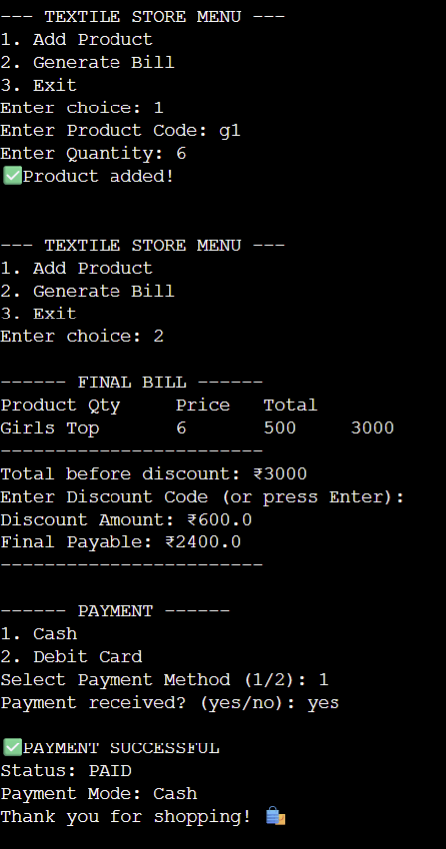

Output 2, card as payment:

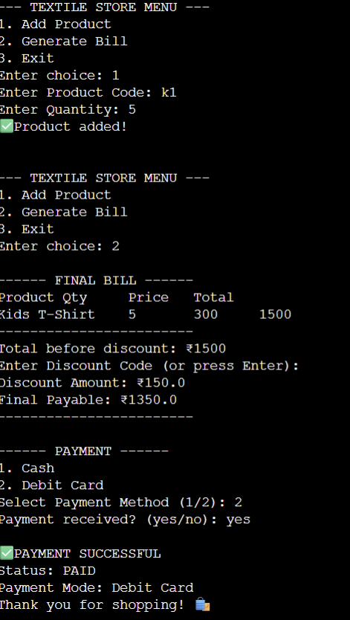

FUTURE WORK

While the current implementation of the Textile Store Billing System successfully automates basic billing operations, there is significant scope for further enhancement to improve its functionality, usability, and real-world applicability.

One of the major improvements that can be made is the development of a Graphical User Interface (GUI). The present system operates through a command-line interface, which may not be convenient for all users. By implementing a GUI using frameworks such as Tkinter or PyQt, the system can provide buttons, forms, and visual elements, making it more interactive and user-friendly.

Another important enhancement is the integration of a database management system such as MySQL or SQLite. Currently, product details and transactions are stored temporarily in the program. By introducing a database, the system can store product information, customer details, and transaction history permanently, enabling better data management and retrieval.

The system can also be extended to include an inventory management module. This feature would allow automatic tracking of stock levels, updating quantities after each purchase, and generating alerts when stock is low. This would help store owners manage their inventory more efficiently.

In addition, support for advanced payment options can be added. The current system supports only cash and debit card payments. Future versions can include digital payment methods such as UPI, credit cards, mobile wallets, and online payment gateways, making the system more aligned with modern transaction practices.

Another possible enhancement is the implementation of a billing receipt generation system. The system can be modified to generate printable or digital receipts in formats such as PDF, which can be shared with customers for record-keeping.

The project can also be expanded into a web-based or mobile application using technologies like Flask, Django, or Android development frameworks. This would allow users to access the system from anywhere, increasing its usability and scalability.
Furthermore, adding user authentication and security features such as login systems for admin and staff can improve data protection and restrict unauthorized access.

Advanced features like sales analytics and reporting can also be included. These features can provide insights into daily sales, popular products, and revenue trends, helping store owners make better business decisions.

Finally, the system can be enhanced by incorporating barcode scanning and automation technologies, which would further speed up the billing process and reduce manual input.

CONCLUSION

The Textile Store Billing System project successfully demonstrates how programming can be effectively applied to solve real-world problems in the retail sector. The primary objective of this project was to design and develop a simple, efficient, and user-friendly billing system that automates the process of product selection, bill generation, discount calculation, and payment handling in a textile store. Through the implementation of this system using Python, the project achieves all its intended goals and provides a practical solution to the limitations of manual billing methods.

One of the key accomplishments of this project is the automation of billing operations, which significantly reduces the chances of human errors that are common in traditional manual systems. By allowing users to select products, input quantities, and automatically calculate totals, the system ensures accuracy and reliability in every transaction. The inclusion of both automatic discounts and discount codes further enhances the system’s functionality, making it adaptable to real-world business practices such as promotional offers and customer incentives.

The project also emphasizes the importance of modular programming and structured design. Each functionality, such as adding products, generating bills, and processing payments, is implemented as a separate function. This not only improves code readability and maintainability but also makes it easier to extend the system with additional features in the future. The use of Python data structures like dictionaries and lists demonstrates an efficient way of handling product information and customer transactions.

Another significant outcome of this project is the implementation of a menu-driven interface, which makes the system simple and interactive. Even users with minimal technical knowledge can operate the system without difficulty. The inclusion of multiple payment options, such as cash and debit card, reflects real-world transaction scenarios and adds to the practicality of the application.

In addition to its functional benefits, the project serves as an excellent learning experience in applying programming concepts to develop a complete software solution. It enhances understanding of core concepts such as input handling, conditional logic, loops, functions, and data structures. Moreover, it highlights the role of software systems in improving efficiency, accuracy, and customer satisfaction in business environments.

Despite its simplicity, the Textile Store Billing System lays a strong foundation for future enhancements. With further development, such as integrating graphical user interfaces, databases, and online payment systems, the project can evolve into a comprehensive retail management solution.
In conclusion, the project not only fulfills its objectives but also demonstrates the practical significance of programming in modern-day applications. It provides a reliable, efficient, and scalable solution for textile store billing while showcasing the potential of Python as a powerful tool for developing real-world software systems.

